Chapter 15, Solution 50.

Take the Laplace transform of each term.

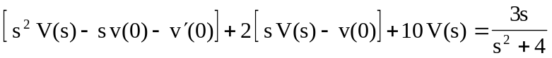
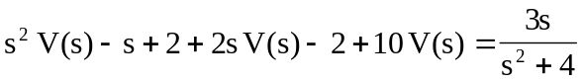
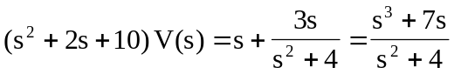
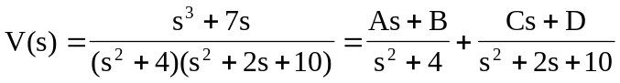

Equating coefficients :
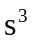: 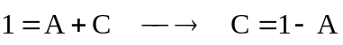
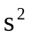: 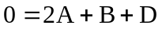
:
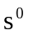: 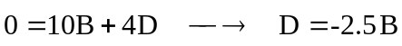

Solving these equations yields
 